User Manual

**Introduction** **3**

**About This Manual** **3**

**Application Description** **4**

**Intended Application Users** **5**

**Users Unsupported by the Application** **5**

**Application Operating Environment** **6**

**Outcomes of Application Use** **6**

**Application Limitations** **6**

**Overview of Technical Features** **7**

**Overview of User Interface Features** **7**

**Description of peripherals** **8**

Bluetooth Therapy Buttons 8

Low Friction Therapy Surface 9

**System Requirements** **10**

How to install or set up the software 10

**Task: Switch user.** **14**

**Troubleshooting Switch User.** **14**

**Task: Connecting Bluetooth Buttons.** **15**

**Troubleshooting Connecting Bluetooth Buttons.** **15**

**Task: Operating Main Counter** **16**

**Troubleshooting Operating Main Counter.** **17**

**Task: Setup and Completion of Rehabilitation Exercises.** **17**

**Troubleshooting Setup and Completion of Rehabilitation Exercises.** **18**

Task: Add a user. 19

Troubleshooting Add a User. 20

Task: Delete User 20

Troubleshooting Delete User. 21

Task: Show User Statistics 22

Troubleshooting Show User Statistics. 23

Task: Data Export 24

Troubleshooting Data Export. 25

General Troubleshooting. 25

# Introduction

This program is designed to help stroke patients recover their mobility. Current research indicates that early exercise training is critical to patient recovery after a stroke. This project provides graded functional training for all stages of rehabilitation. This project aims to help increase muscle strength and restore athletic ability for stroke patients. This project incorporates feedback elements into each training phase to maximize the enthusiasm of the training process.This project transforms the training process into signals that can be perceived (such as sound, light, and images), and then allows patients to learn to control their own involuntary functions based on these signals by adding cognitive and sensory training.

The project runs on an iPad, which provides versatility. The project could guide the user to complete specific actions based on a predefined rehabilitation plan to help the recovery process. The application uses a series of Bluetooth buttons to sense the user's actions and determine if the user's actions are meeting the standards. This project also could accurately record every valid action completed by the user and gives the user appropriate positive feedback. When the user completes a task, the relevant data will be recorded to the iPad for inquiry.

# About This Manual

This user manual is intended to serve as a detailed guide for the operation of the stroke rehabilitation application. It will provide step-by-step instructions on how to perform all of the primary functions of the application. It will also provide the user with information about how to install and run the application using its required hardware and peripherals. This manual will also provide a detailed troubleshooting guide and address frequently asked questions in order to minimise the need for external help and maximise the time spent successfully operating the application.

This manual is intended to be read by typical users of the stroke rehabilitation application. This primarily includes stroke patients as well as medical professionals setting up and administering stroke rehabilitation therapy. Secondarily, this manual is intended for other people such as friends, family and caregivers who may use this manual to help stroke patients use the application, set it up for them, or train them in its use. The manual assumes a basic level of technological skill, such as having used other iPad applications. It is likely a patient will require help in operating this application if they have never interacted with an iPad, or similar device before.

This manual only provides details on how to operate the application from the perspective of the users. It does not provide technical information about the application, its development or its extensibility. For detailed technical information about this application, including source code documentation, development guides, and lower-level design details, please refer to the Technical Manual. Any developers or testers interested in modifying the source code, extending the application or finding out more technical information should refer to the Technical Manual.

# Application Description

The purpose of this application is to provide a means to increase the total time a stroke patient spends undergoing stroke rehabilitation therapy. The use of this application is intended to allow therapists to treat more patients with higher frequency. The therapist sets up and administers a therapy session using the application and can leave the patient to complete the exercises unattended while the therapist moves to their next patient. After the patient completes their therapy session, the therapist can return to review details about the completed session at a later time. The application also allows for patients to set up and perform their own therapy if they wish, to maximise total time spent undergoing therapy.

Therapy is performed through the actuation of two force-sensitive touchpads which are attached to a specialised low friction surface in front of the patient. The patient will move their hand from one touchpad to the other to complete reps for their therapy session. These touchpads are connected wirelessly to an iPad which is placed at the back of the low friction surface area but facing the user. This allows space for the user to move their arms and actuate the buttons but still see and interact with the iPad.

The iPad is running the stroke rehabilitation application. This application primarily serves as a counter for the touchpads. The application will record and count the number of repetitions completed by the user, and display it on the screen. The application also provides visual and audio feedback when a touchpad is actuated or a rep is completed.

While the application allows for a user to quickly and easily start the application and begin performing therapy immediately, the user may also set up a customised session by inputting specific time and rep targets. For example, a user may decide to create a therapy session where the goal is to complete 20 reps in 2 minutes.

Finally, the application has the ability to create user profiles, login, and store session information for the specified user. This information is automatically recorded when a user has logged in, and can be reviewed and exported from the iPad at a later time.

## Intended Application Users

The application is intended for use by stroke patients to perform therapy to improve their mobility and overall prognosis, by facilitating hand movement therapy exercises. This application will not be appropriate for all stroke patients, depending on their current cognitive and physical capabilities, their goals for their therapy, as well as many other medical, social, physical and personal factors. It is the discretion of the patient’s therapist and other medical professionals that should decide whether the application is appropriate to be used for their patient.

The second primary user of this application is stroke rehabilitation therapists who wish to use this application to administer therapy to their patients. The therapist may set up user profiles for their patients as well as custom sessions with predetermined time and rep goals. The therapist may also review a patient's session history, see statistics summarising their patient’s performance, and export these details from the iPad to another device.

The application may also be used by other caregivers, as well as friends, family, loved ones, and other people who wish to assist the stroke patient in using the application and performing stroke rehabilitation therapy.

## Users Unsupported by the Application

All users who wish to use this application should first seek a professional opinion. This application is not appropriate for all users and could result in slowed rehabilitation progress, halted progress, or injury. If you experience any excessive pain or discomfort using this application, discontinue use and seek advice from your therapist before continuing.

This application was designed, tested and developed for use by stroke patients. Therefore, using this application to assist with other ailments and conditions goes beyond its intended use and must be approved by a medical professional.

Some stroke patients may not have sufficient cognitive and physical functionalities to properly operate the application. These people should not use the application unless directed by a medical professional.

Ultimately it is up to Physiotherapists to decide if the use of this application is something that could benefit a patient, and they should use their personal discretion to decide if the use of this app is suitable or not.

## Application Operating Environment

The application is intended for use in a hospital setting. Patients will perform stroke rehabilitation exercises on-ward under the supervision of a therapist. The force-sensitive touchpads, the low-friction therapy surface and the ipad will be set up in front of the user, either attached to their bed or to a chair. It is intended for the therapist to set up the rehabilitation session in person, leave the patient to perform the exercises, and return once the session is complete to review statistics.

In its current state, the application is not intended for use outside a hospital setting. It is also not designed for use without the supplementary force-sensitive touchpads and low friction therapy surface. Finally, this application is not intended for use without the assistance of a medical professional.

## Outcomes of Application Use

The application is designed to supplement other stroke rehabilitation methods and assist in improving arm mobility in acute stroke patients. The primary aspect that facilitates this is the ability to perform rehabilitation exercises without the direct supervision of a therapist, so more time can be spent by a patient performing therapy. This, in turn, benefits the therapist who does not need to be present for the entire duration of a patient’s therapy session, and can move on to another patient or activity.

## Application Limitations

The following is a list of limitations of the application in its current form.

* The application cannot be properly used without the supplementary force-sensitive touchpads or low friction therapy surface.
* The application does not support any other devices other than the iPad.
* The application does not currently support any other form of stroke rehabilitation exercise other than hand movements.
* The application does not support any other form of external peripheral other than the force-sensitive touchpads.
* The force-sensitive touchpads must be connected via to the iPad via Bluetooth.
* The force-sensitive touchpads must be charged and switched on before use.
* The application is still in early stages of development and may be subject to bugs, limited functionality and change.
* The application requires touch input which may not be possible for some users.

## Overview of Technical Features

The following is a list of the technical features and functions of the application. For more information, see the Walkthrough section of this manual.

* Quick session screen
* Increment a counter when a rep is completed
* User profiles
* Display user session history and statistics
* Export user session history and statistics
* Custom session screen
* Set rep goals and time limits
* Supports Bluetooth therapy buttons

## Overview of User Interface Features

The following is a list of the user interface and usability features of the application. These features are mostly intended to facilitate stroke victims' limited cognitive and physical capabilities, as well as potential technical incapability. Additionally, some features are intended to incentivise use. For more information, see the Walkthrough section of this manual.

* Clean and simple interface
* Large text and simple language
* Begin therapy immediately upon launch of application
* Visual and audio feedback upon button actuation
* Minimal required iPad interaction
* Self-dismissing popups and dialogues
* Progression bars to visualise the user’s progress
* Minimal presentation of negative progression or feedback

## Description of peripherals

### Bluetooth Therapy Buttons

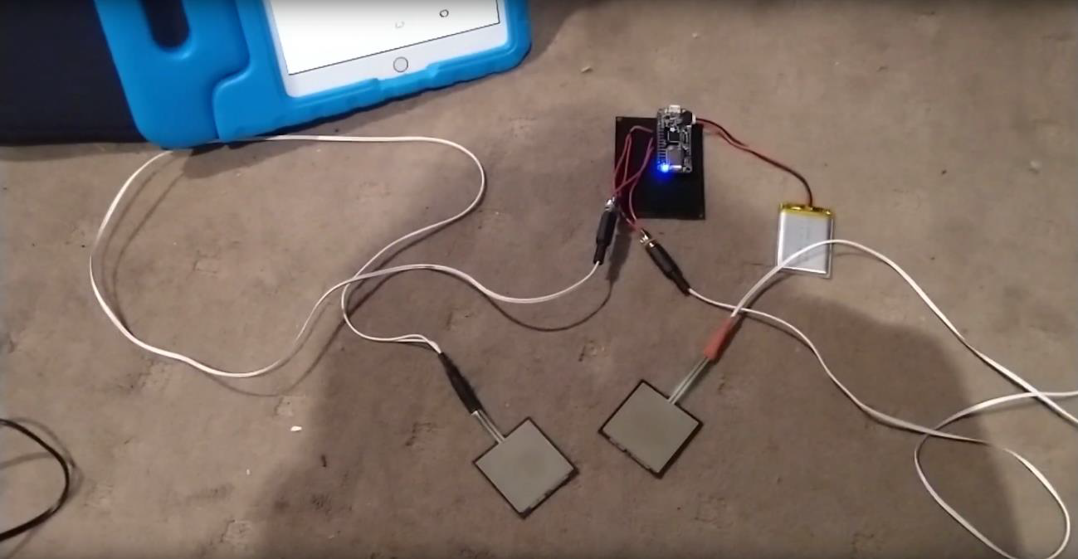

Figure 5. Bluetooth Therapy Buttons

The Bluetooth Therapy buttons are integral to the use of the stroke rehabilitation application. They are what is used to record arm movements during rehabilitation therapy. Once a user touches one button then the other, the application registers that as one completed rep and increments a counter.

The buttons themselves are force-sensitive pads that measure approximately 4cm square and are slightly thicker than a piece of paper. These pads are wired to an Arduino controller using a 3.5mm plug. When pressure is applied to these pads, a signal is sent from the pad to the Arduino controller. The Arduino controller then sends a signal to the iPad via Bluetooth to register that button press on the stroke rehabilitation application.

The force-sensitive pads are attached to the low friction therapy surface in locations determined by the therapist, using adhesive tape. It is intended for the patient to move their arm between the pads, actuating them, to perform rehabilitation exercises.

The Bluetooth therapy buttons must be correctly plugged into the Arduino controller; the Arduino controller must be charged and switched on; and the Arduino controller must be connected to the iPad via Bluetooth for the buttons to function.

### Low Friction Therapy Surface

### 

Figure 6. Low Friction Therapy Surface

The low friction therapy surface is a specially designed surface used for performing stroke rehabilitation exercises. It is made from materials that minimise friction, in order for the stroke patient to be able to slide their hand across the surface with minimal effort. The Bluetooth therapy buttons will be attached to this surface at locations determined by the therapist, using adhesive tape. The patient would then move their hand between the buttons, acuating them to register reps on the application and perform their therapy exercises.

Currently, there are two types of low friction therapy surfaces, one that attaches to a patient’s hospital bed, and one that attaches to a chair. This creates a surface in front of the patient with which to perform therapy exercises.

The surface also has an area, at the far end from the user, to attach and prop up the iPad. This allows the iPad to be interacted with and viewed, but prevents it from getting in the way of rehabilitation exercises.

## System Requirements

The following is a list of hardware and software that is required for successful installation and operation of the stroke rehabilitation application:

* Apple iPad
  + iPadOS version 13 or newer:
    - iPad Air 2 or newer
    - iPad (5th Generation) or newer
  + Bluetooth turned on and connected to Bluetooth Therapy Buttons
  + Landscape mode
  + Sound turned on
  + Lightning cable for installation
* Apple Mac (for application installation)
  + MacOS 10.14 or newer
  + iTunes 10.12 or newer
  + The application .ipa file
* Bluetooth Therapy Buttons (Adafruit Feather 32u4 Bluefruit with force-sensitive resistors)
  + Buttons connected to controller
  + Controller charged, switched on and broadcasting Bluetooth signal

A description of how to install or set up the software; (Reuben)

Software Setup Guide

1. Ensure that the bluetooth buttons are charged, and turned on.
2. Open the application on the provided iPad.
3. Press the bluetooth icon and select the buttons from the list of devices.
4. You are now able to proceed with setting up patient for therapy.

## How to install or set up the software

Although it may be released on the App Store at some point, currently, this project will be released in the form of an ipa package which users might download via the Internet or obtain a hard copy through a distributor.

Make sure have the ipa file on your macOS computer (desktop/laptop). Make sure that your iPad is connected to your Mac through iTunes. Now you should be able to see the ipa file on your computer. As you should see in figure 1.

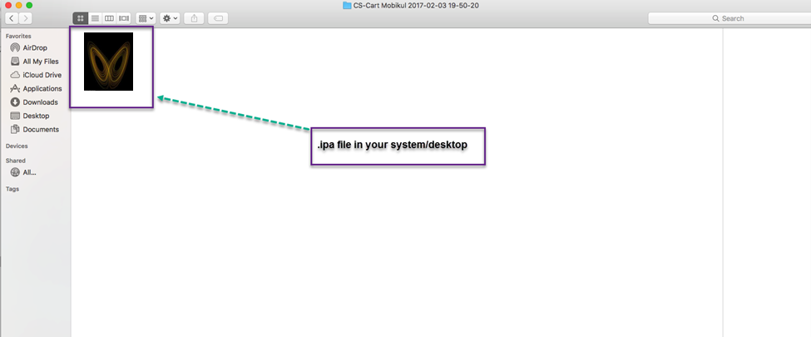  
Figure 1. The ipa File Shown on the Mac.

Open the ipa **file** with **iTunes** as described in figure 2.

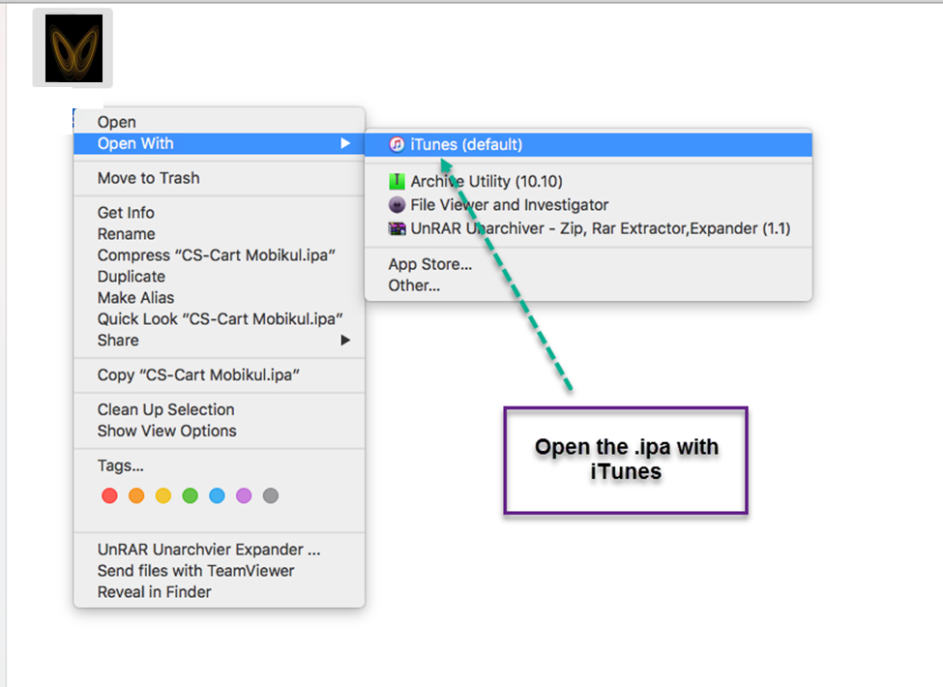

Figure 2. Opening the ipa File with iTunes.

After clicking on Open with iTunes you should then be able to find the ipa file in the **Apps** section of **iTunes**. As shown in figure 3.

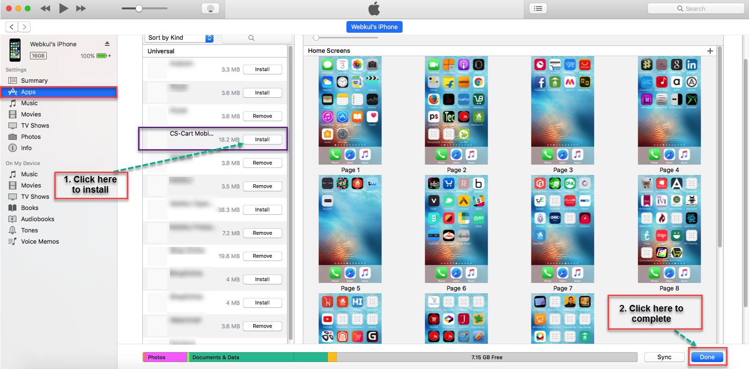  
Figure 3. Locating and Installing the ipa File in iTunes.

Once you can see the **application** in the **Apps** section of iTunes, you can click on the **install** button and click on the done button to proceed.

Now check the iPad device connected to iTunes. The Application should be transferring to your iPad, and will be ready to use once complete.

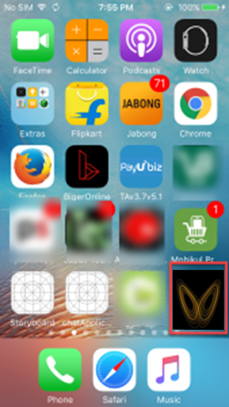  
Figure 4. The App on the iOS Device.

## **Task: Switch user.**

Step 1: Open the application to the main counter screen.

Step 2: Tap on the user icon on the top left outlined in red (right)

Step 3: The currently logged in user is shown on the profile screen below in blue. 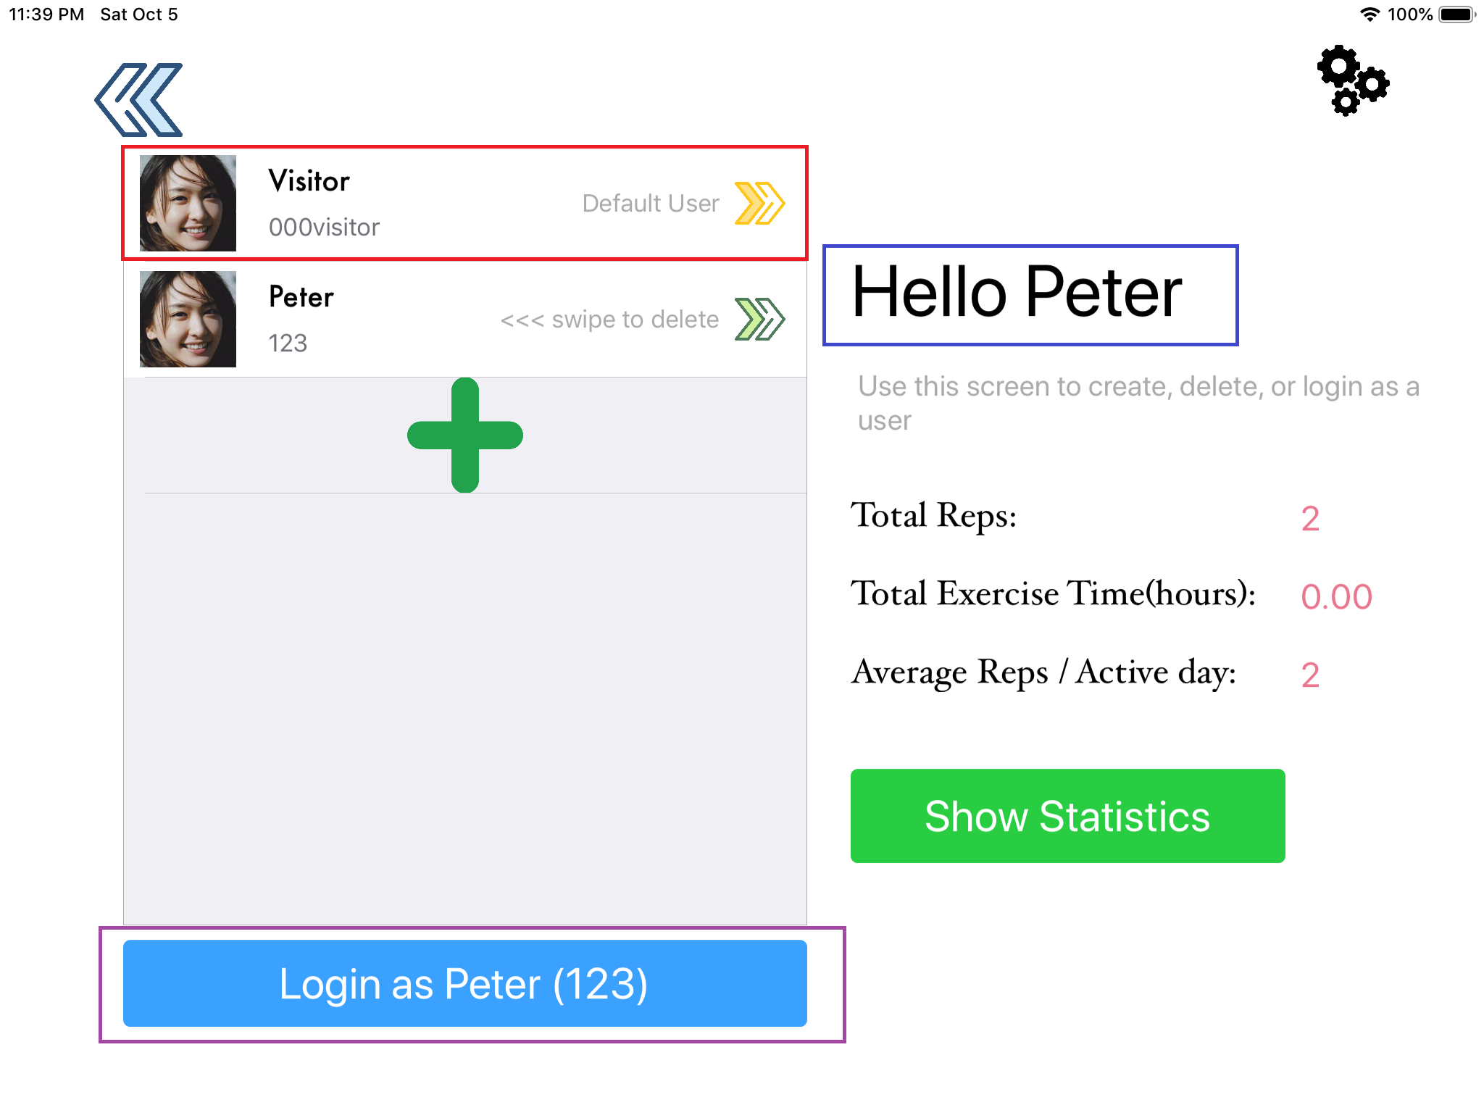

Step 4: Select the user you would like to switch to by tapping on the icon outlined in red (above)

Step 5: To login with the new user; tap the ‘Login as’ button outlined in purple (above)

### **Troubleshooting Switch User.**

**Restart the application -**

Step 1: Navigate the iPad back to the home screen.

Step 2: Terminate the Stroke Rehabilitation app.   
 Step 3: Re-open the Stroke Rehabilitation app.

Step 4: Repeat steps 1-5 outlined in Task: Switch User.

**Switching to another user -**   
Sometimes if you have more than two users, switching to another user may allow you to switch to your desired user.

Step 1: Repeat steps 1-3 outlined in Task: Switch User.

Step 2: Select a seperate user as outlined in step 4 of Task: Switch User.

Step 3: Login with that user as outlined in step 5 of Task: Switch User.

Step 4: Repeat steps 2 and 3 with the desired user.

## **Task: Connecting Bluetooth Buttons.**

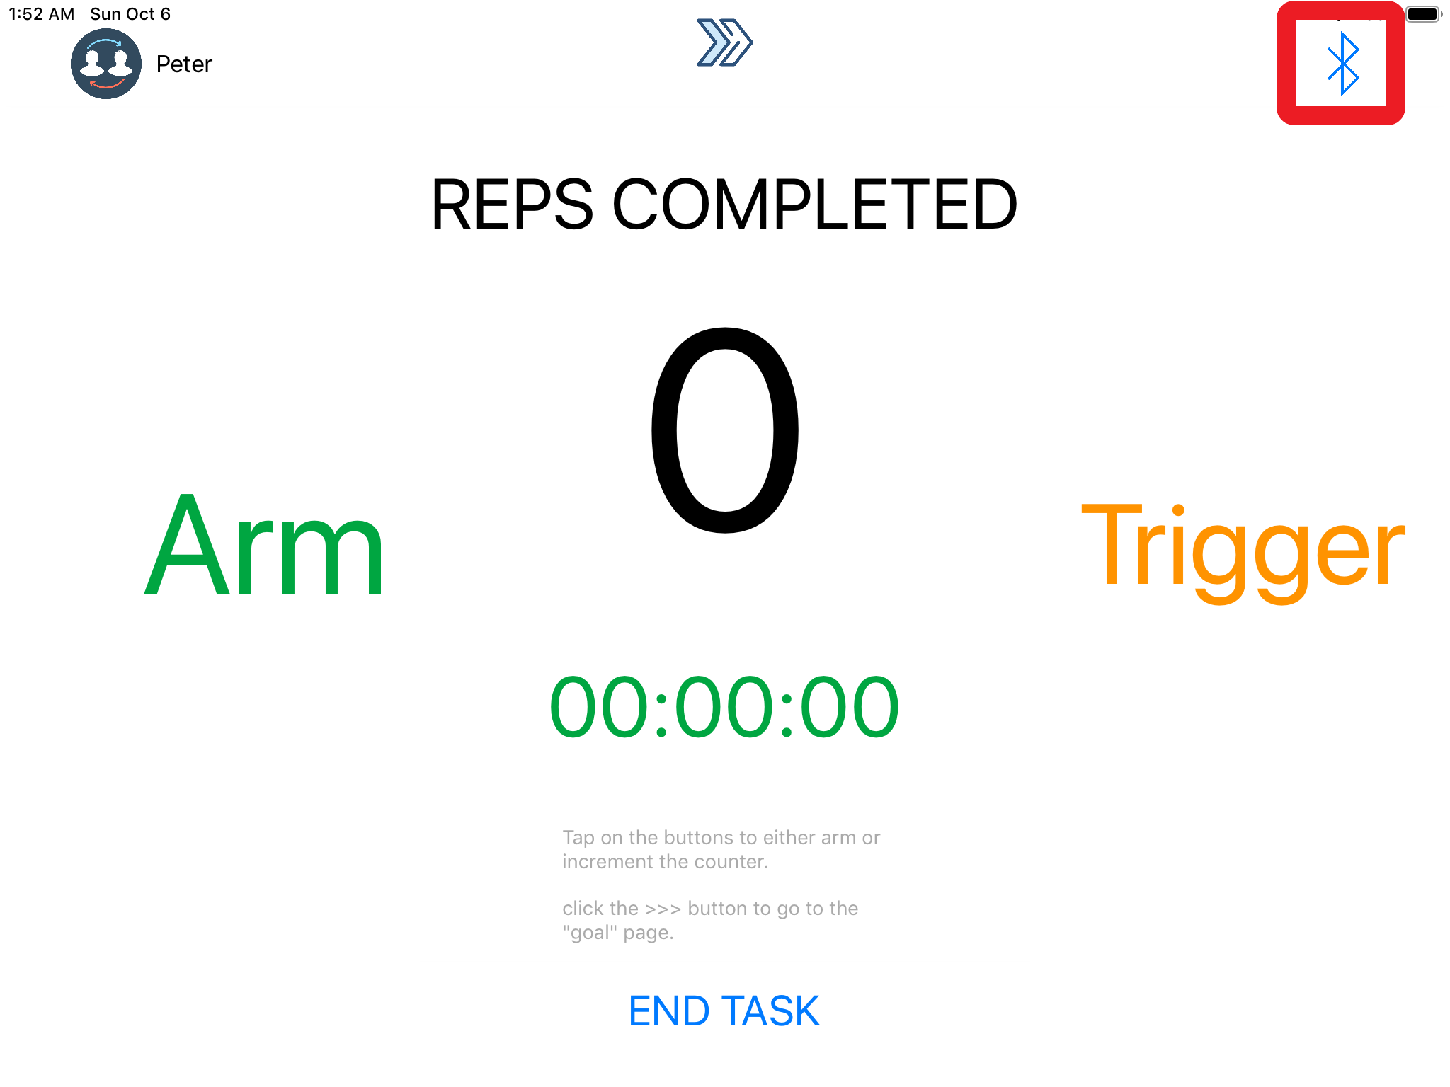

Step 1: Open the application to the main counter screen.

Step 2: Tap on the Bluetooth icon in the top right corner of the app (right).

Step 3: Externally to the application:

Step 3.1: Ensure the Bluetooth Buttons are charged.  
 Step 3.2: Power on the Bluetooth Buttons.

Step 4: Wait for the application to detect the Bluetooth buttons.

Step 5: Once the buttons are connected the application should appear as below and a prompt will notify the user that the buttons were connected successfully. 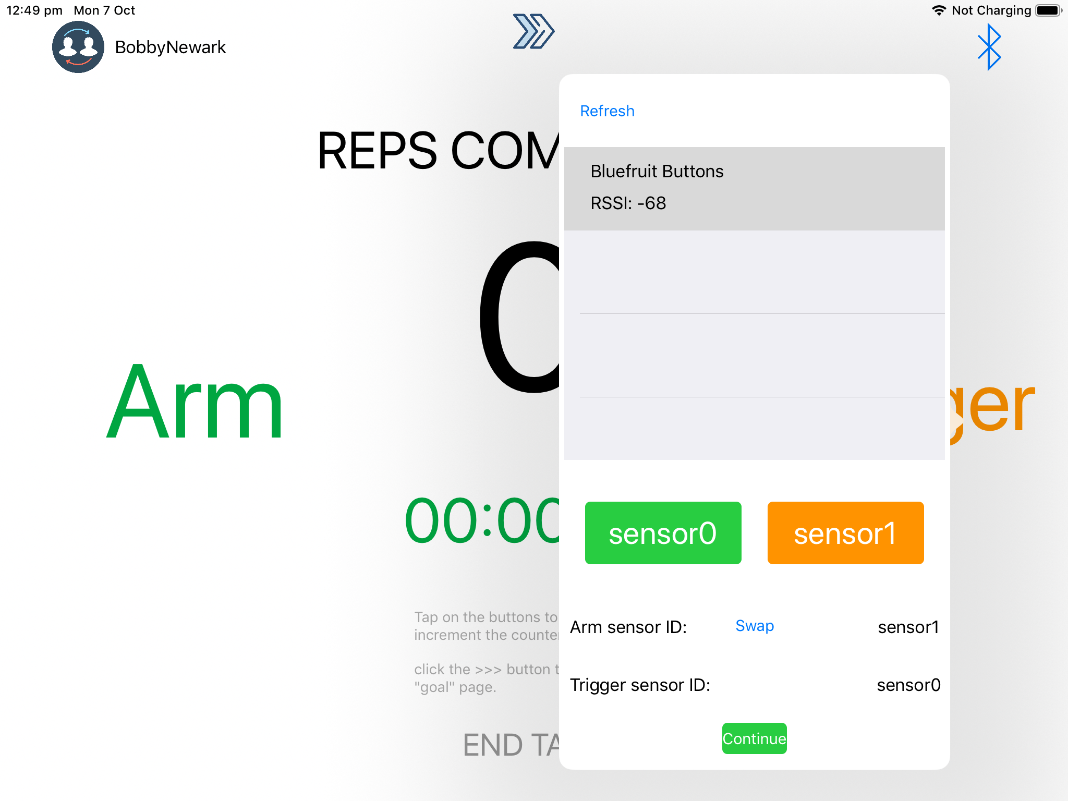

Step 6: Return to the previous screen by tapping the ‘Continue’ button (above).

### **Troubleshooting Connecting Bluetooth Buttons.**

**Restart the Bluetooth Buttons -**

Step 1: Ensure the buttons are sufficiently charged (indicated by the LED on the device).  
 Step 2: Turn the buttons off by using the switch on the device.  
 Step 3: Wait two minutes before powering the buttons back on.   
 Step 3.1: If the buttons are low on power; charge the buttons.  
 Step 4: Turn the buttons back by using the switch on the device.   
 Step 5: Repeat steps 1-5 of Task: Connecting Bluetooth Buttons.

**Restart the iPad -**

Step 1: Exit the Stroke Rehabilitation application.   
 Step 2: Turn the iPad off.   
 Step 3: Wait 2-5 minutes.   
 Step 4: Turn the iPad back on.   
 Step 5: Reopen the Stroke Rehabilitation app.  
 Step 6: Repeat steps 1-5 of Task: Connecting Bluetooth Buttons.

## **Task: Operating Main Counter**

Step 1: Open the application to the main counter screen.

Step 2: Ensure that the Bluetooth buttons are setup (see task: connecting Bluetooth Buttons)

Step 3: Press the button that has been set to have ‘Arm’ functionality. Auditory and visual feedback should reflect a successful action (below left).

Step 3.1: It is possible to also use the onscreen buttons to actuate the timer.

Step 4: Press the button that has been set to have ‘Trigger’ functionality. Auditory and visual feedback should reflect a successful action, and the counter should increment (below right).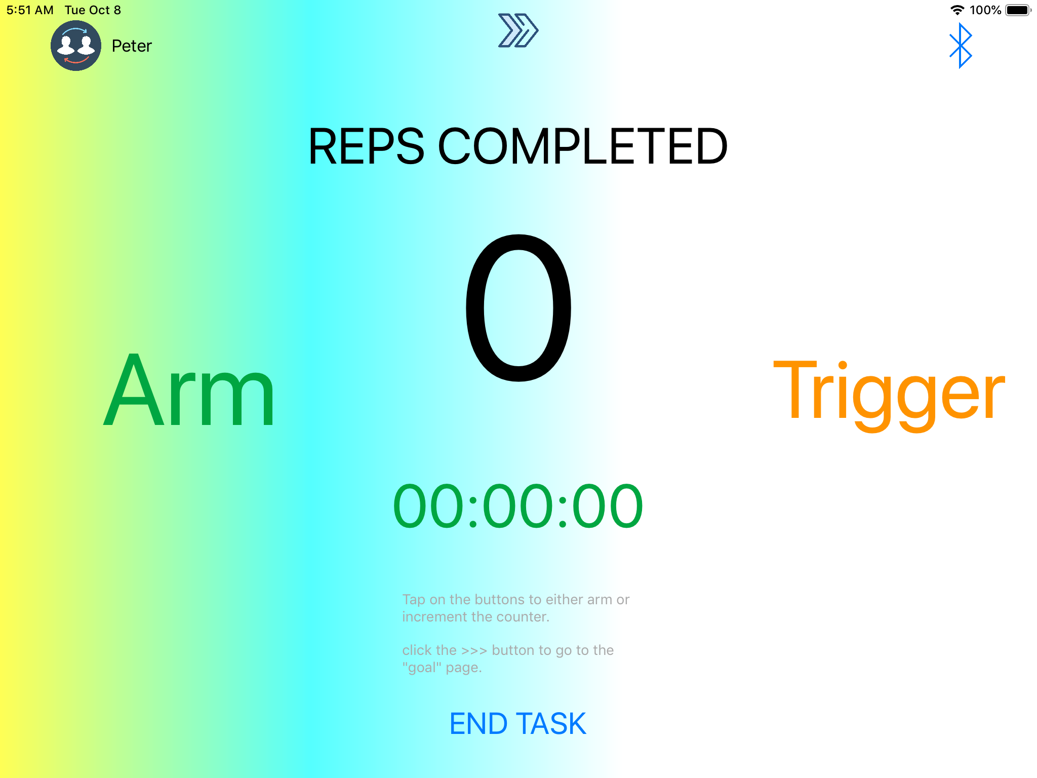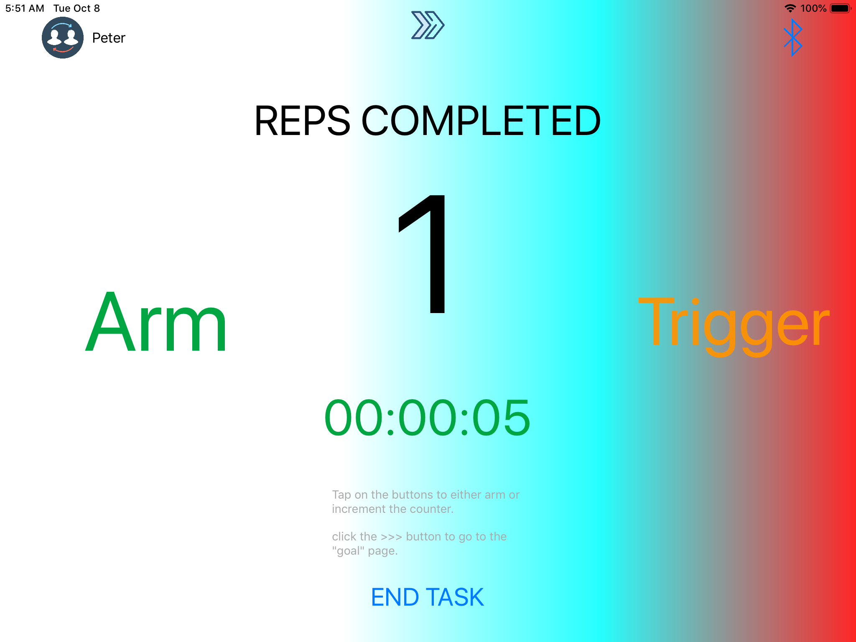



Step 5: To reset the counter at any time, press ‘End Task’ (below).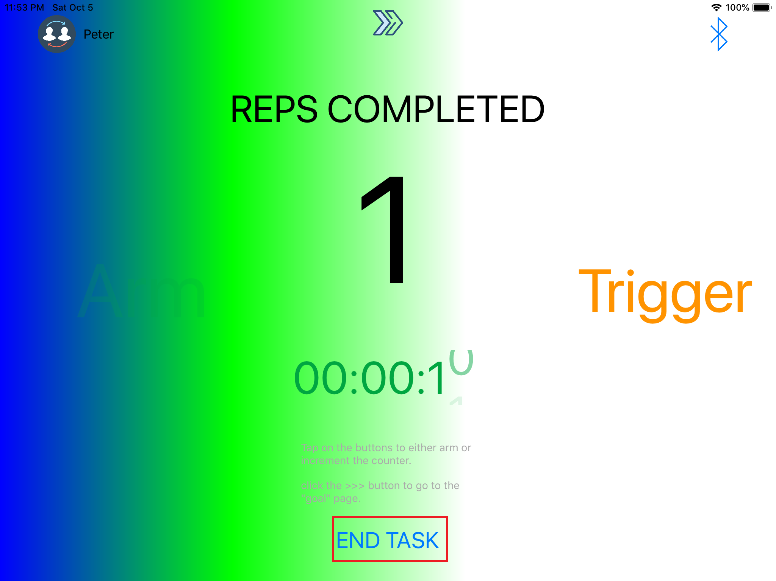

### **Troubleshooting Operating Main Counter.**

**Resolving issues with Bluetooth Buttons -**

See Troubleshooting Connecting Bluetooth Buttons.

**Counter does not increment -**

Step 1: Ensure that the Bluetooth buttons are connected correctly (see above).   
 Step 2: Ensure that you are pressing the buttons in the correct ‘Arm’ - ‘Trigger’ order.   
 Step 3: If the application seems to not be responding or has crashed continue to step 4.   
 Step 4: To resolve the application not responding either:   
 Step 4.1: Follow Restart the Application (see pg14).   
 Step 4.2: Follow Restart the iPad (see pg16).

## **Task: Setup and Completion of Rehabilitation Exercises.**

Step 1: Open the application to the main counter screen.

Step 2: Tap the arrow on the top of the screen to navigate to the goal counter screen (below).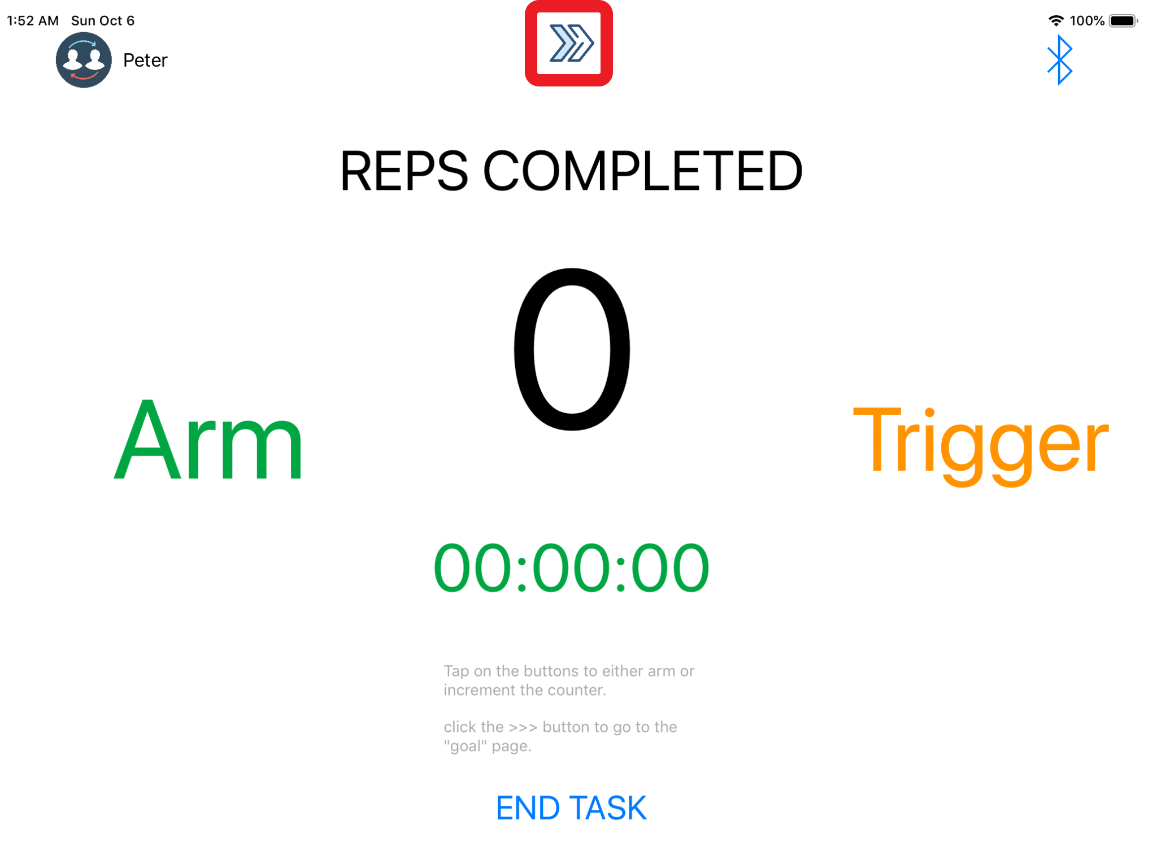

Step 3: On the goal counter, tap the settings icon to open the goal and timer settings screen (below).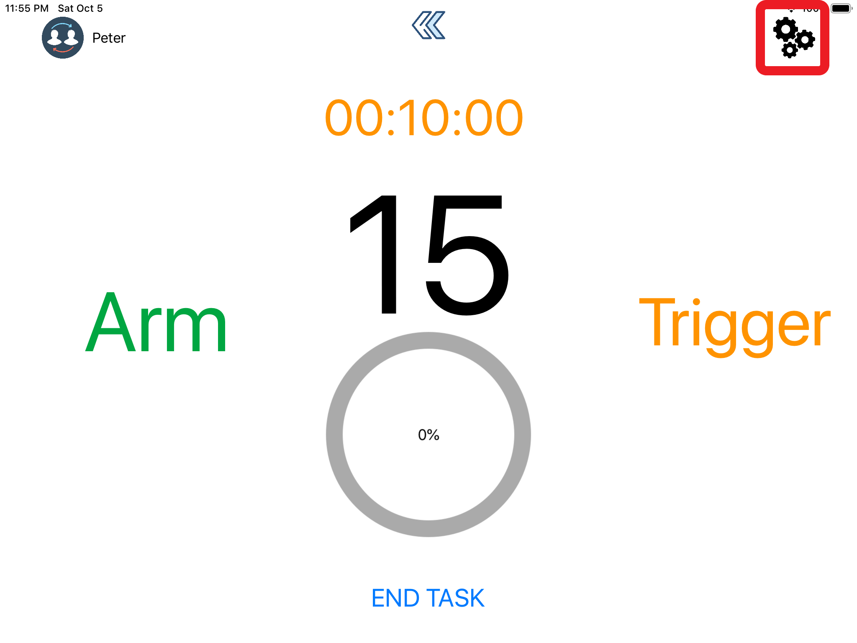

Step 4: To enable the specific functions tap on the radial wheels (below).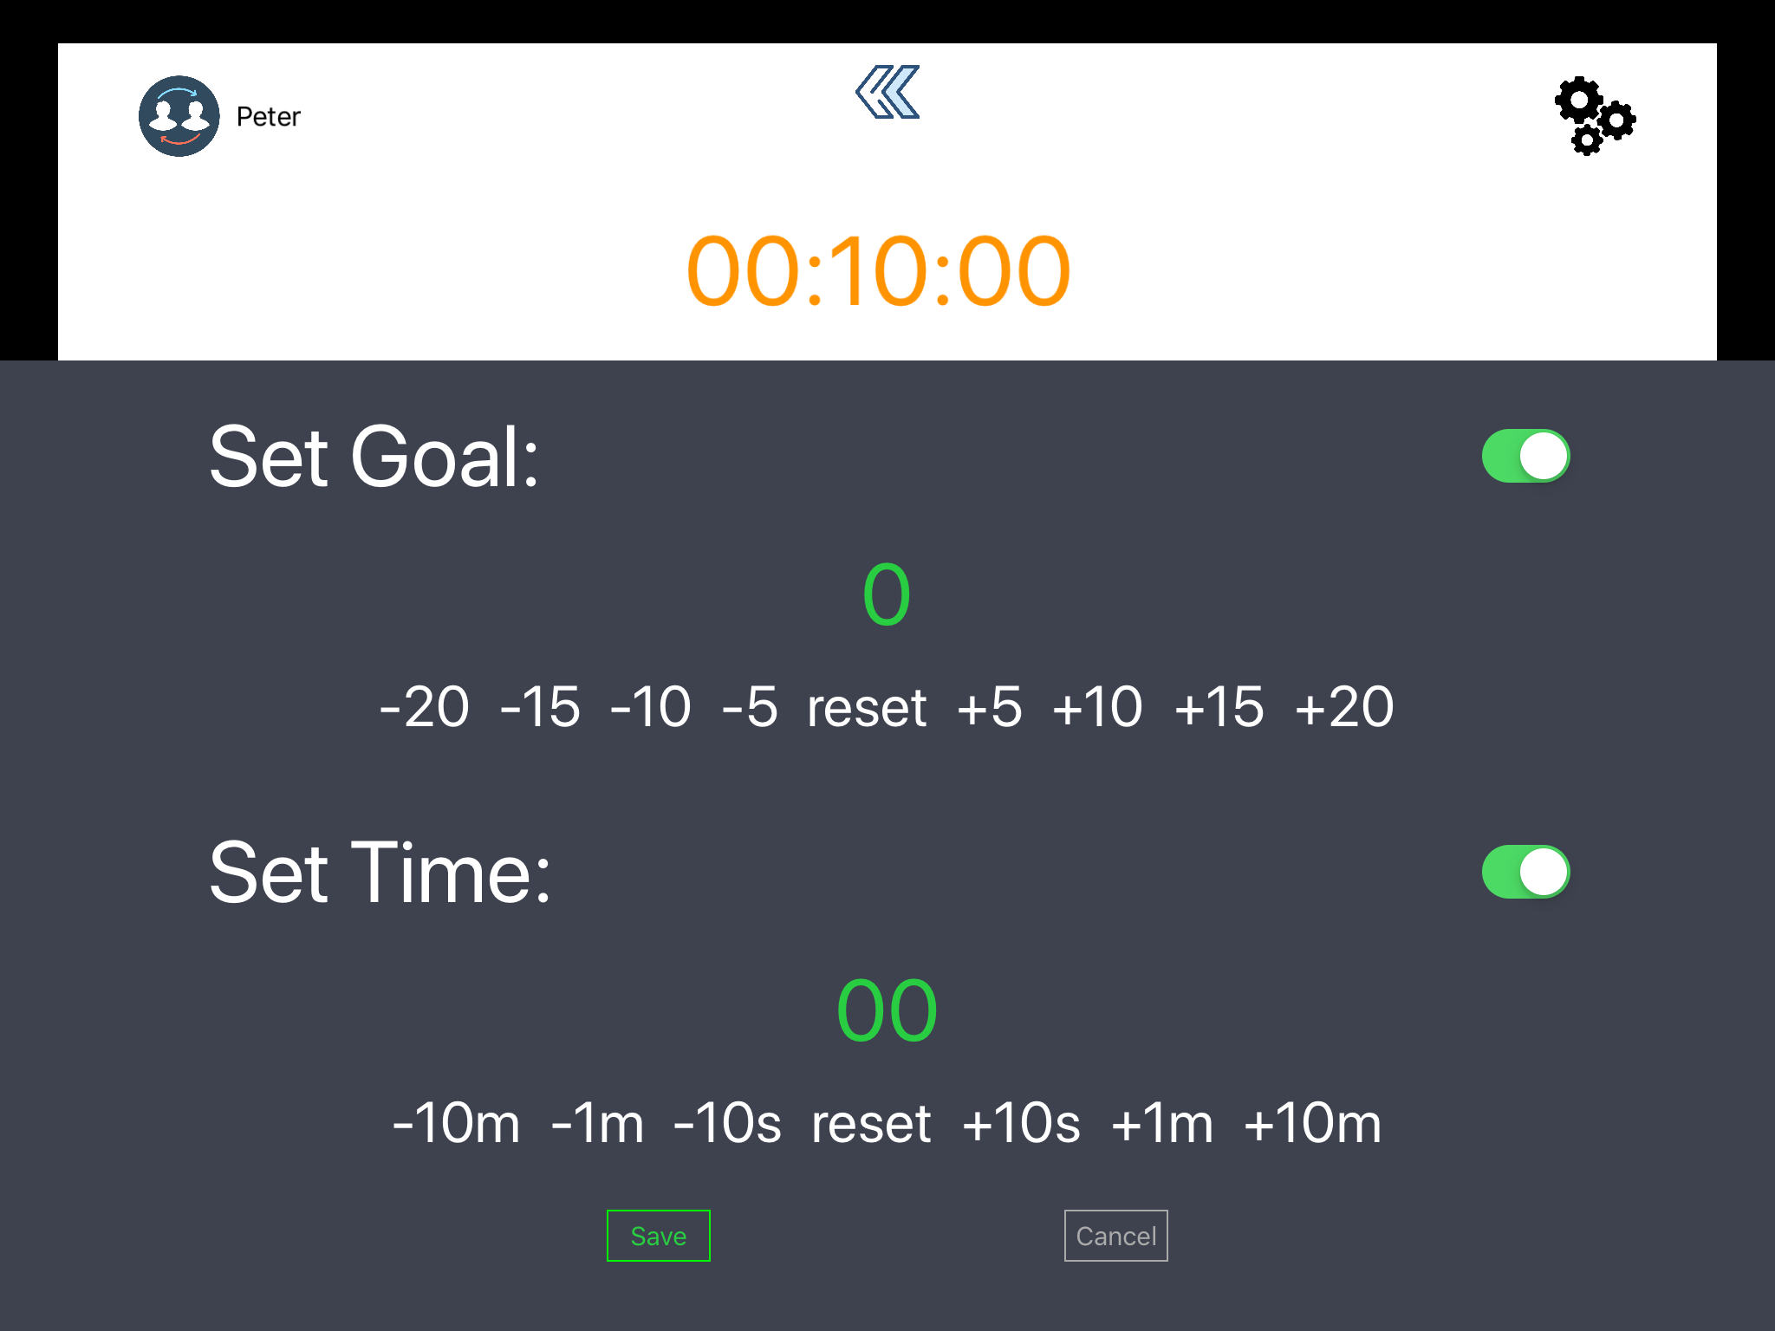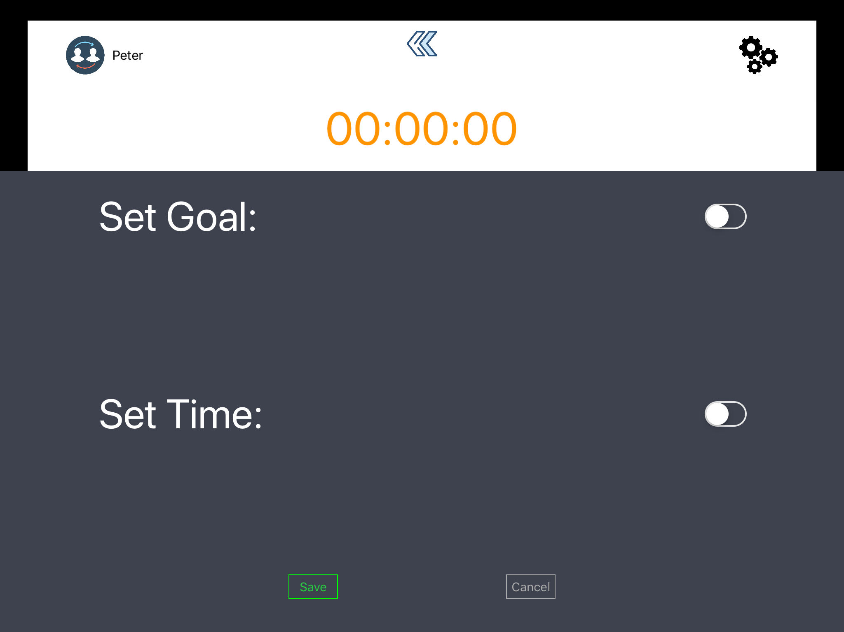

Step 5: Adjust the settings as desired.

Step 6: Either save the settings by hitting the ‘Save’ button (above) or cancel the setup by tapping the ‘Cancel’ button (above).

Step 7: Once saved, you may use the counter in the same way as Task: Operating Main Counter. Note: The set timer will not start until the first repetition has been completed.

### **Troubleshooting Setup and Completion of Rehabilitation Exercises.**

**Settings were not saved correctly -**

Repeat steps 3-7 of Task: Setup and Completion of Rehabilitation Exercises.

**Counter does not work correctly -**

See Troubleshooting Operating Main Counter.

**Timer does not work correctly / Other issues with the goal counter -**

Step 1: Tap ‘End Task’ to complete the session.   
 Step 2: Repeat steps 3-7 of Task: Setup and Completion of Rehabilitation Exercises.  
 Step 3: If the goal counter continues to work incorrectly, restart the application or iPad.   
 Step 3.1: Steps to restart the application or iPad can be found above.  
 Note: Tapping ‘End Task’ will save data that may need to be manually deleted later.

**Unable to set a goal or timer -**

Ensure the goal and timer settings have been toggled.

**Session data was not saved -**

Ensure the session was ended with the ‘End Task’ button or;  
 Ensure the session was ended by reaching the set time limit or;  
 Ensure the correct user is logged in.

**Session data was saved to the wrong day or time -**

Step 1: Navigate out of the Stroke Rehabilitation application.  
 Step 2: Navigate into the devices internal settings.  
 Step 3: Check the internal Date and Time settings of the device.

## **Task: Add a user.**

Step 1: Open the application to the main counter screen.   
Step 2: Tap the user icon on the top left (right).

Step 3: The app will now navigate you to the profile screen. To add a new user, tap the plus icon (below).

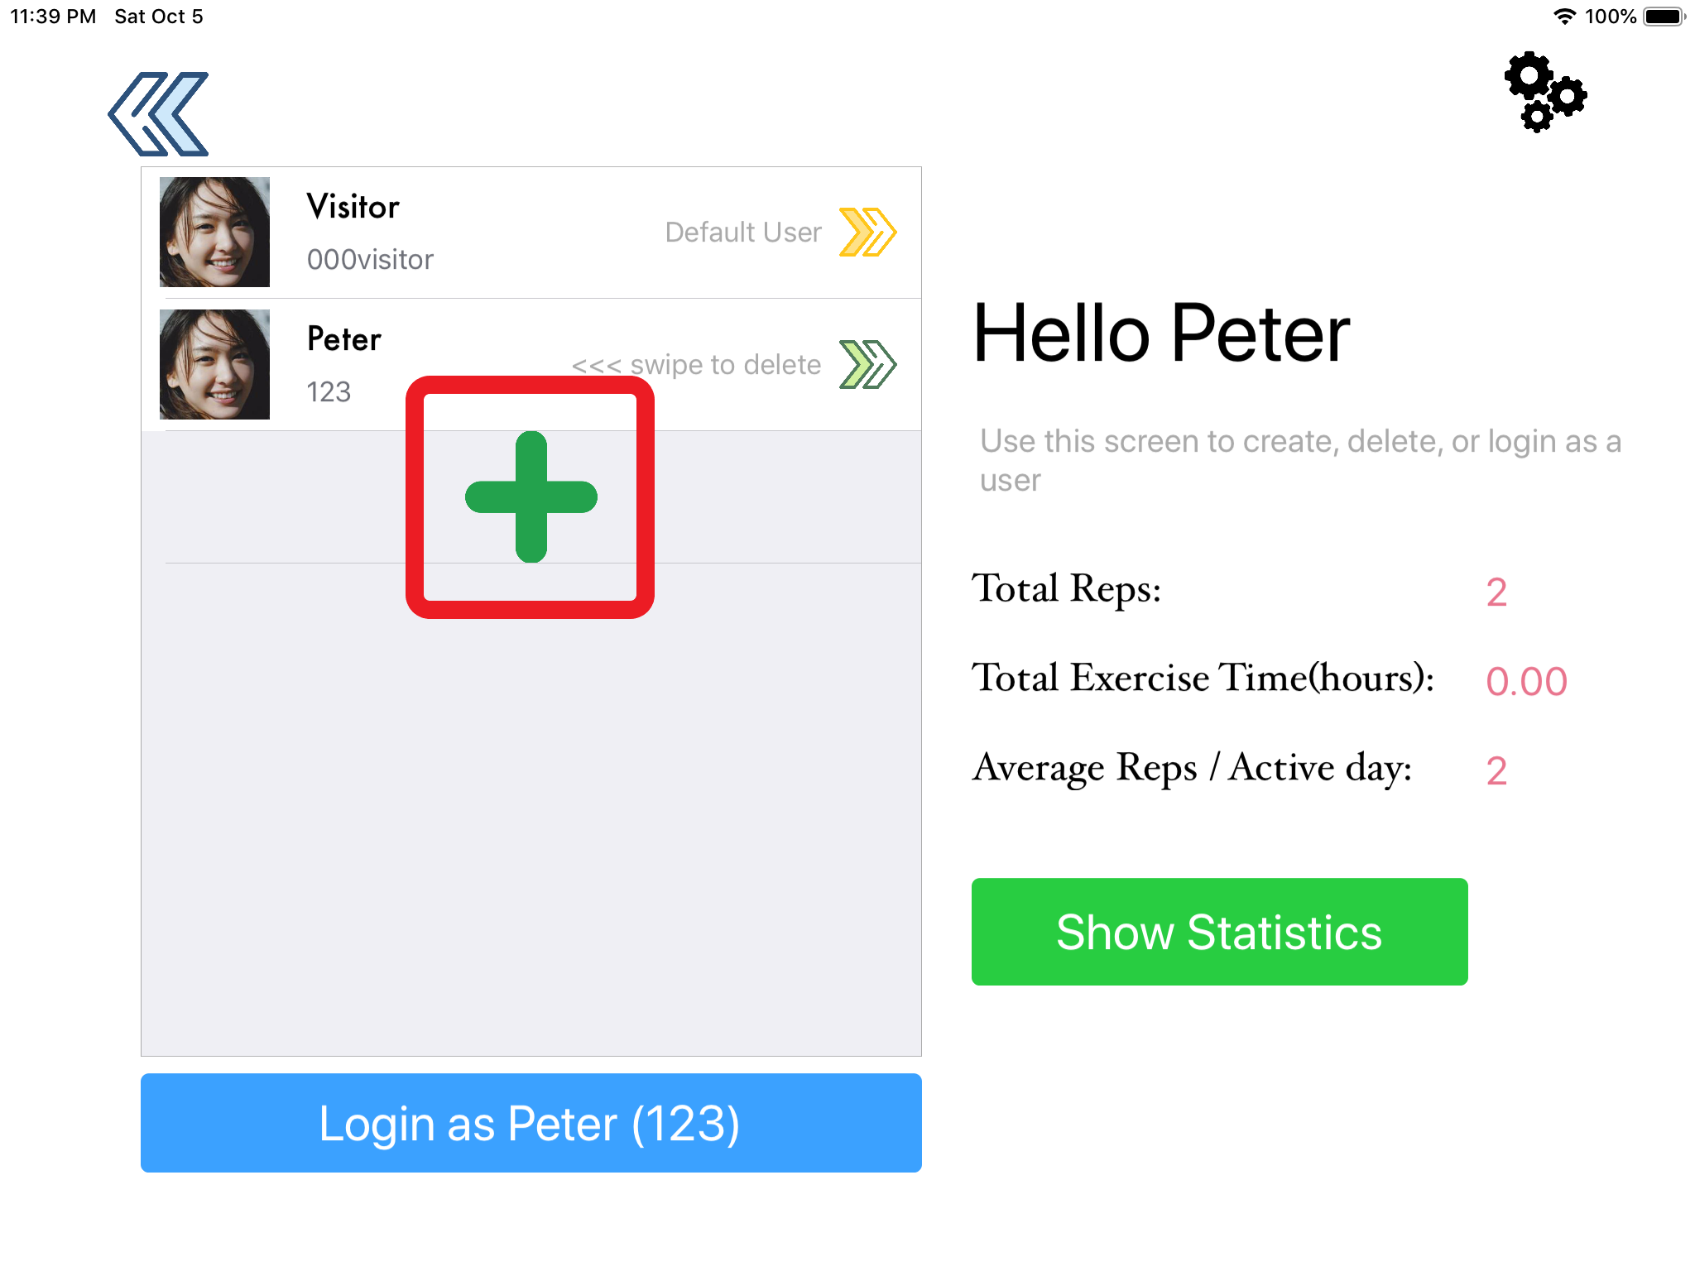

Step 4: Upon selecting the plus icon you will be presented with the user creation form. Fill in the form as desired and then press ‘Create’ (below).

Step 5: Once you have created a new user, you will need to switch to that user and login if you wish to use the application under that profile. This process is outlined in Task: Switch User.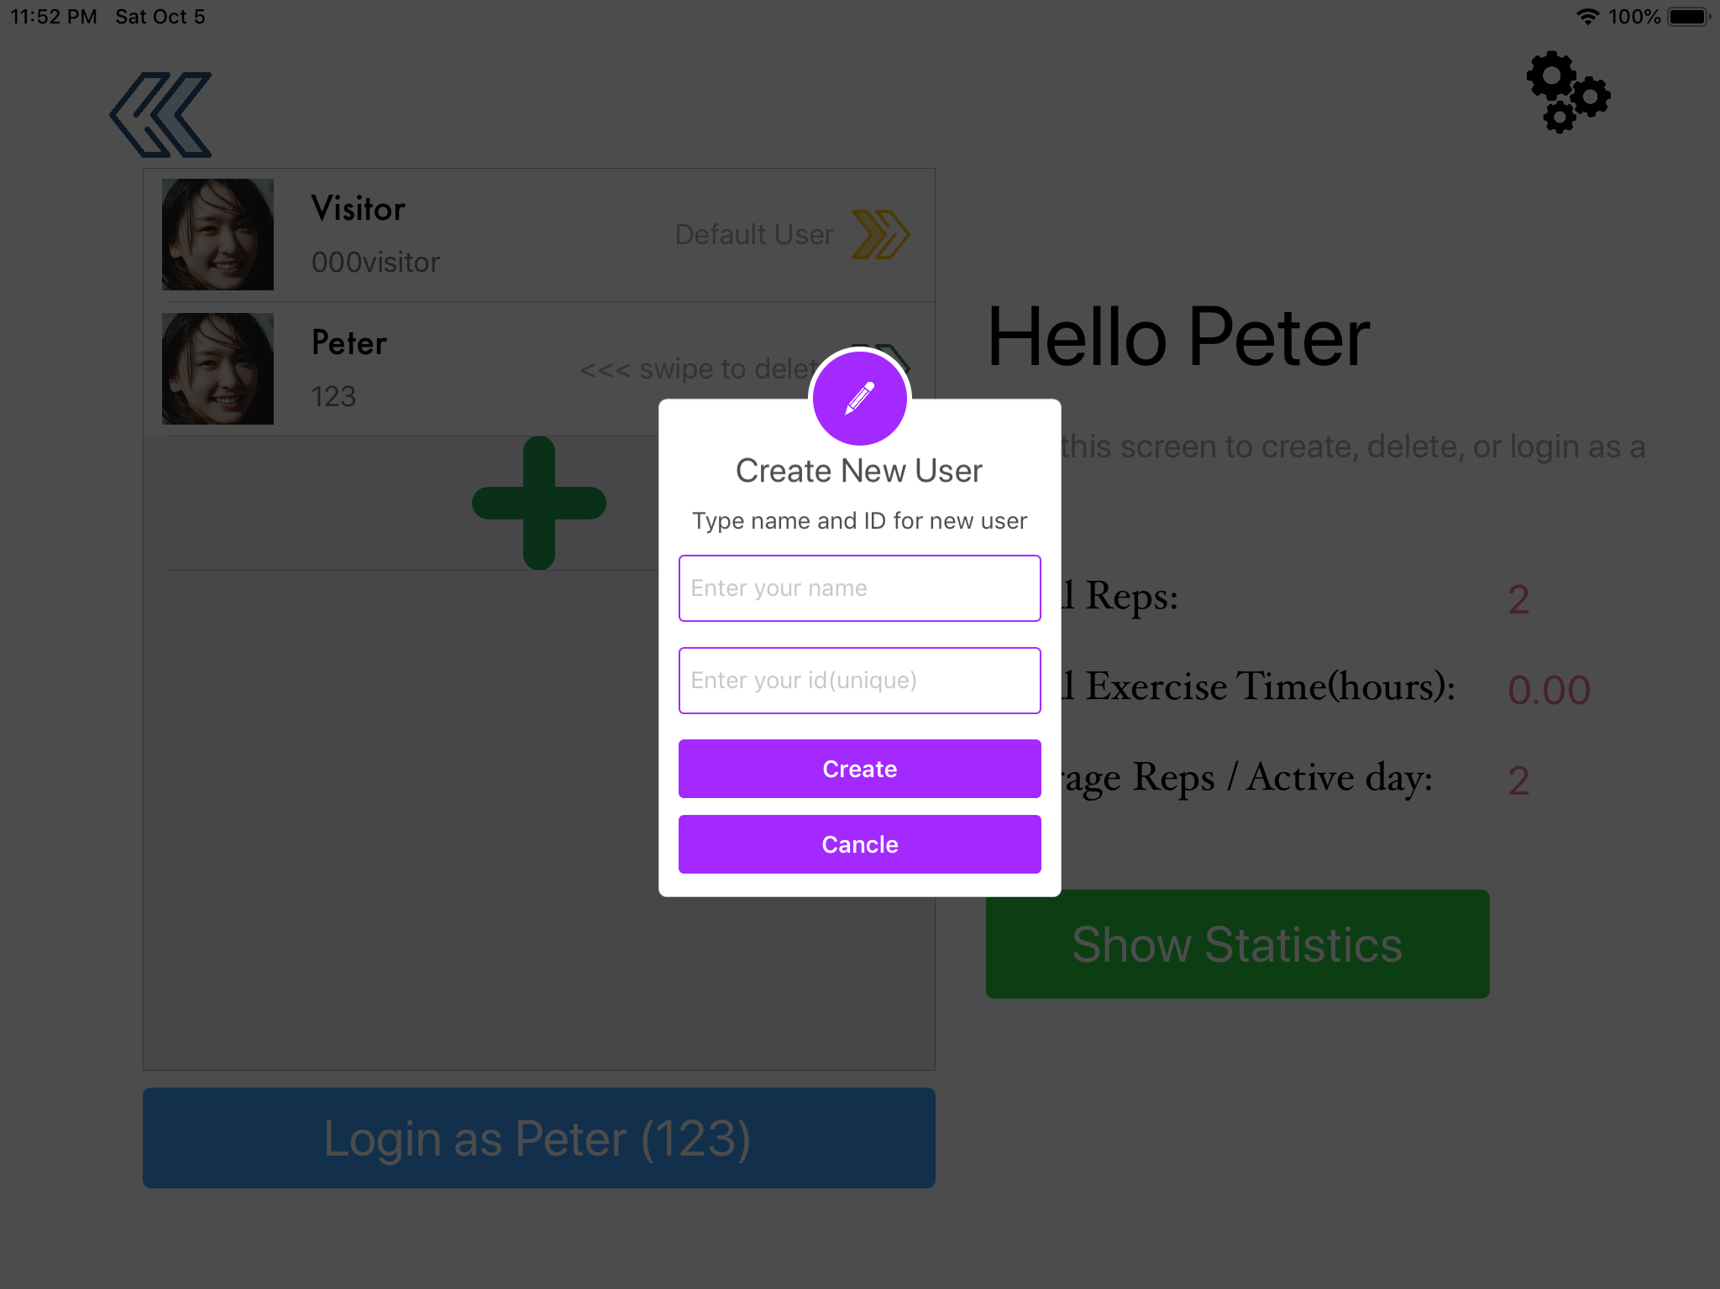

### **Troubleshooting Add a User.**

**The user did not create properly -**

If the user was created, but the data seems corrupt or you are unable to log in:   
 Step 1: Switch user as described in Task: Switch User.   
 Step 2: Delete the corrupted user by following the steps in Task: Delete User.

If the user was not created:   
 Step 1: Repeat steps 4-5 of Task: Add a User.   
 If database is full:

Note: Following these steps may result in permanent loss of data.

Step 1: Delete another user as outlined in Task: Delete User.   
 Step 2: Attempt to create a new user.   
 Note: User’s names can be the same, but IDs must be unique.

**Unable to log into new user account -**

Step 1: Restart the application by following the steps above.   
 Step 2: Check to see if the user is logged in on application start.   
 Step 2.1: If the user is still not logged in; attempt to login again.  
 Step 3: If the above steps do not work, switch to a different user.   
 Step 3.1: Attempt to switch back to the newly created user.

## **Task: Delete User**

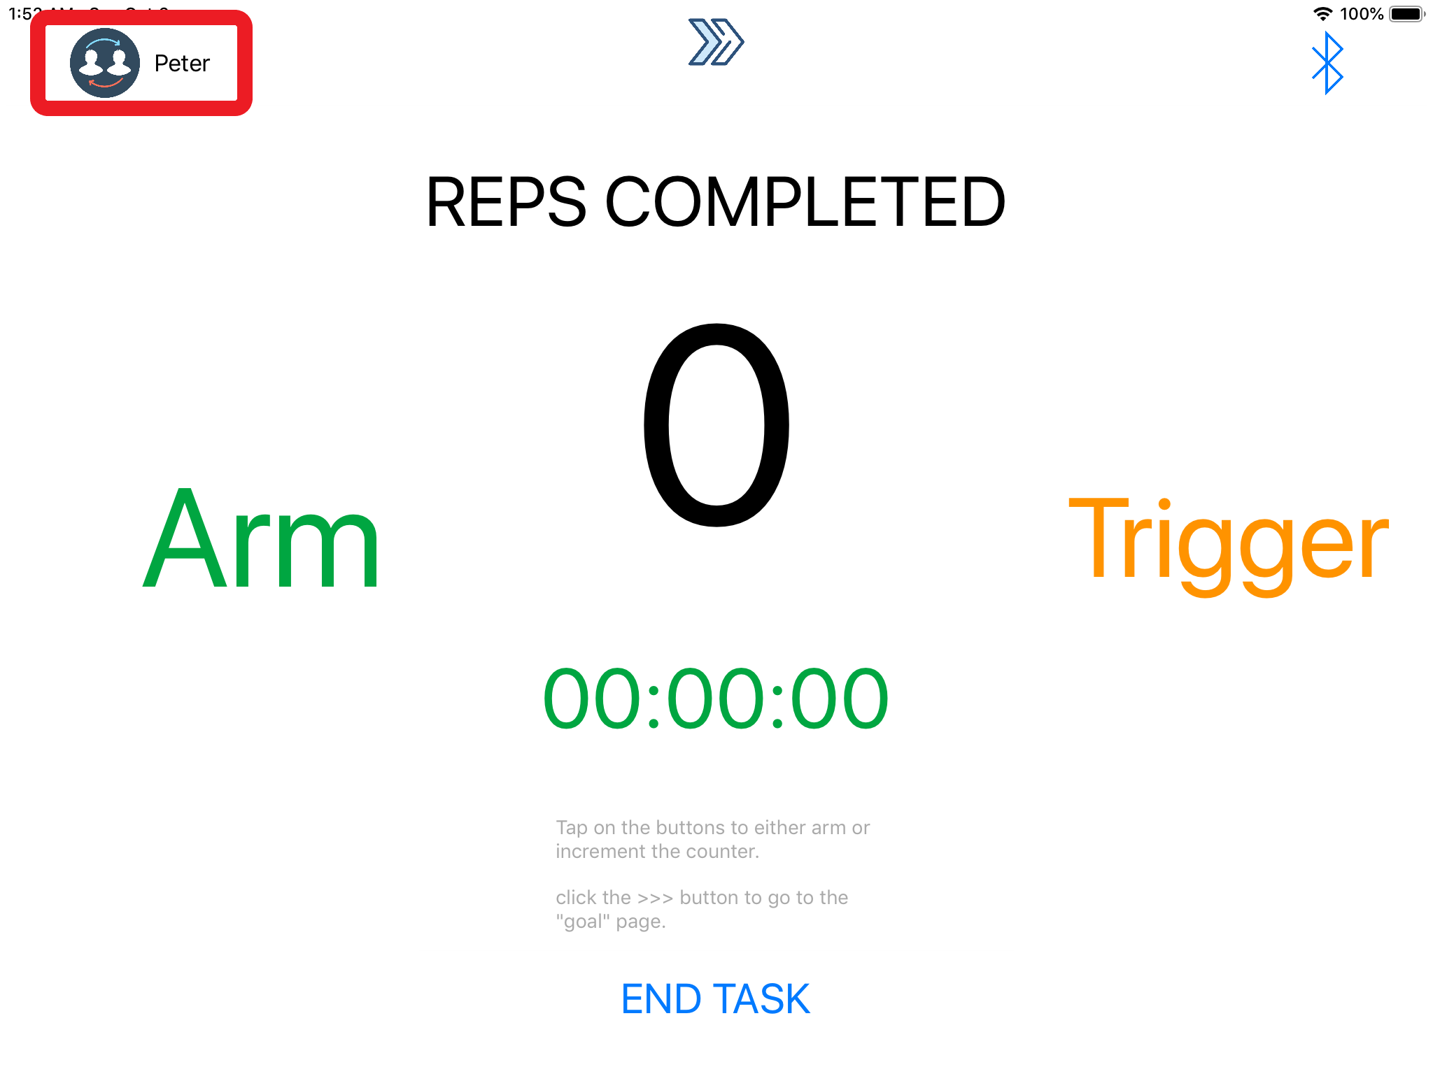

Step 1: Open the application to the main counter screen.

Step 2: Navigate to the profile screen by tapping the user icon in the top left (right).

Step 3: Swipe right on the desired user to reveal the delete icon (below). 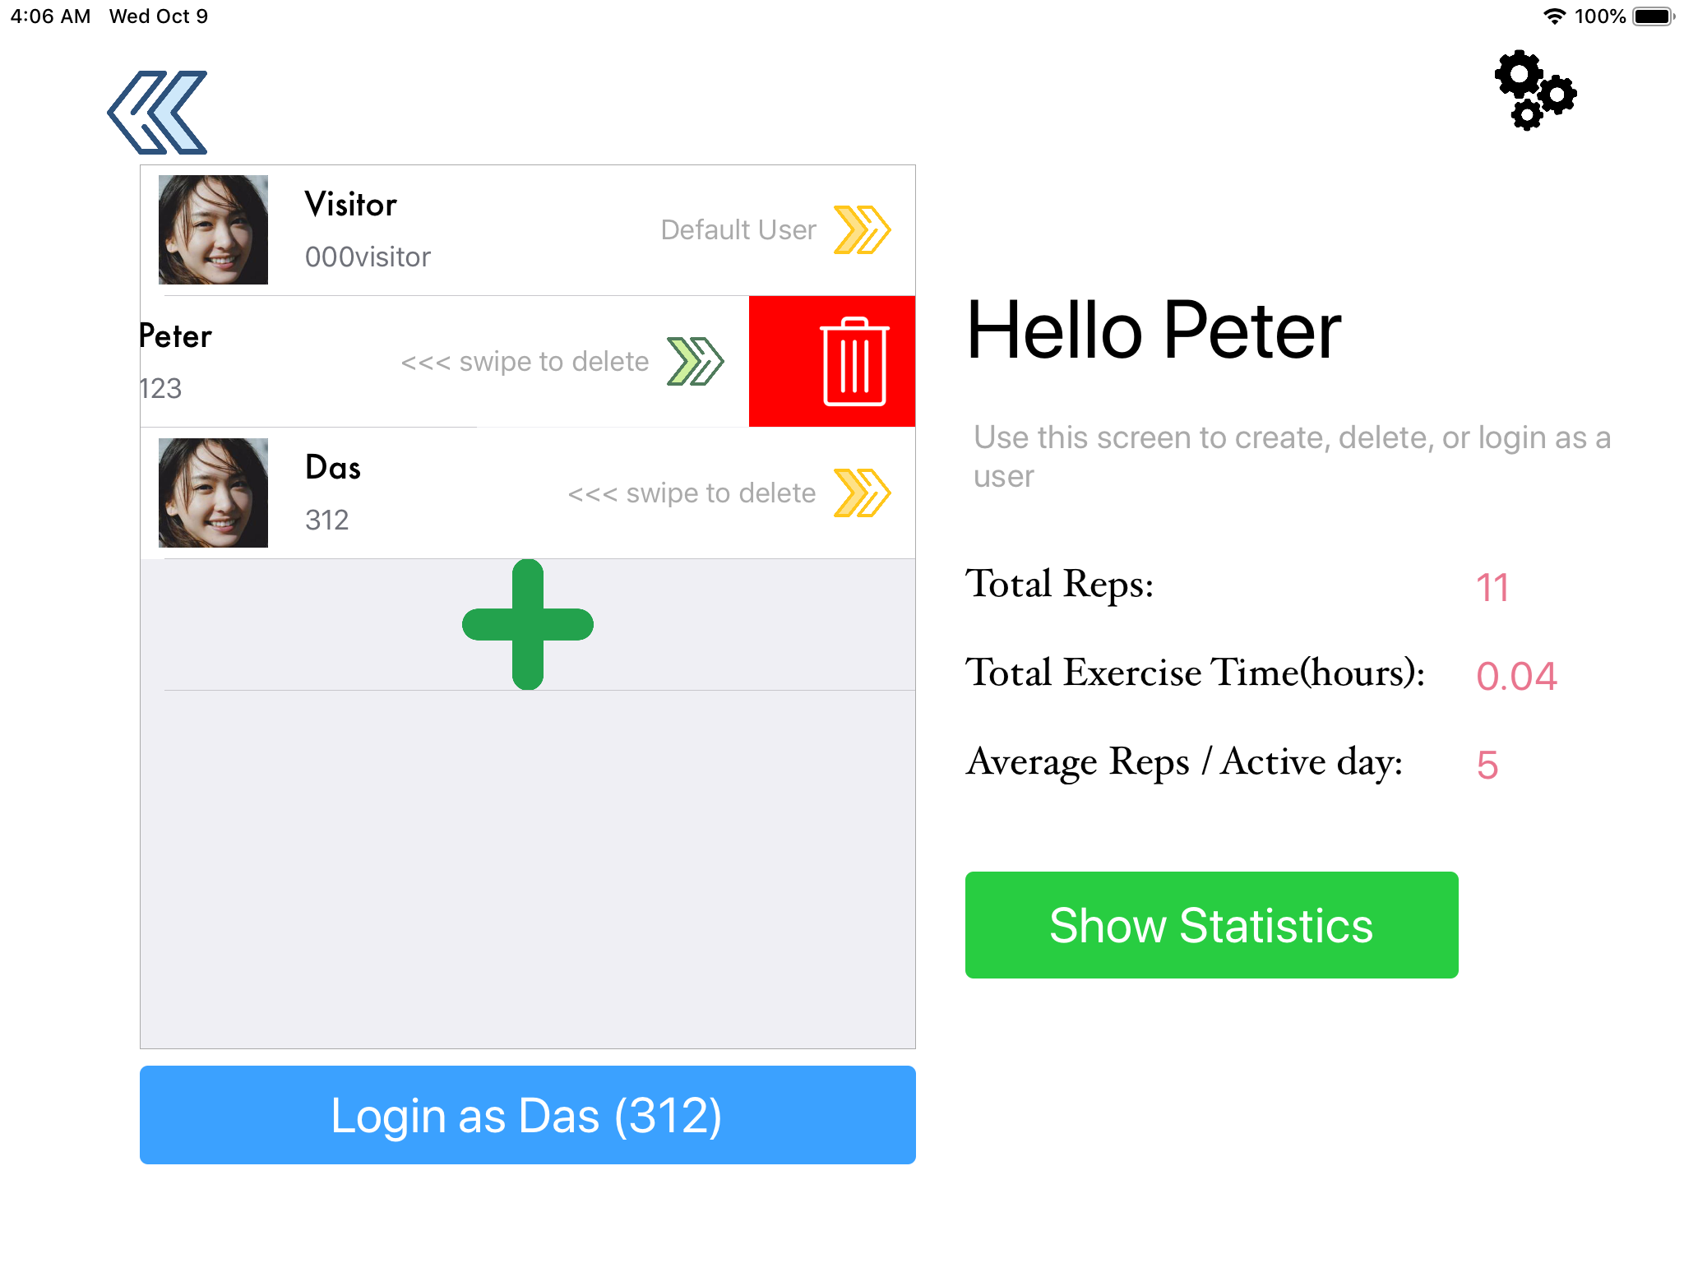

Step 4: Upon tapping the trash can icon, a user delete confirmation message will appear (below). Tap ‘Proceed’ to confirm the deletion, or ‘Cancel’ to cancel the deletion.

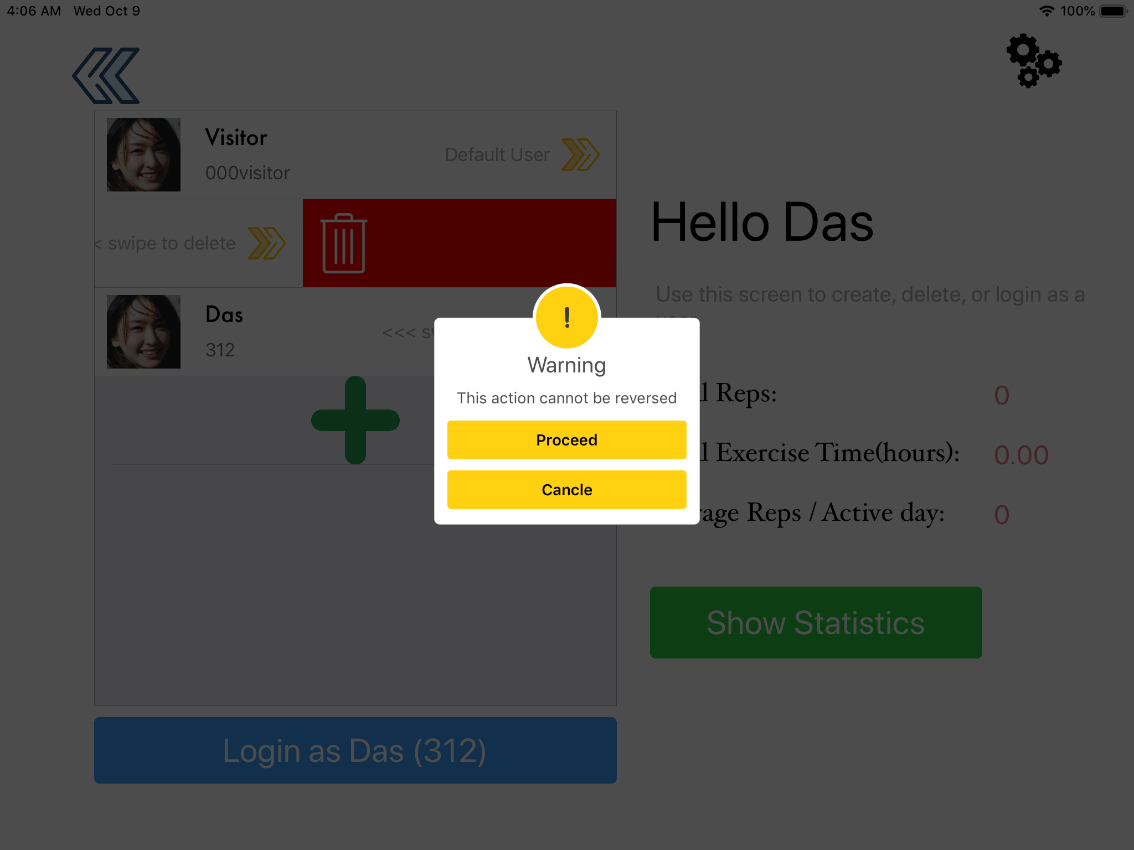

### **Troubleshooting Delete User.**

Note: Deleting a user is permanent.

**User did not delete -**

Repeat steps 3-4 of Task: Delete User.

**Accidental deletion -**

Unfortunately once a user has been deleted, it is deleted forever.

## 

## **Task: Show User Statistics**

Step 1: Open the application to the main counter screen.

Step 2: Tap on the user icon in the top left to access the profiles screen (right).

Step 4: Switch to the user you want to view the statistics of.

Step 5: Basic user statistics can be immediately seen on the right side of the screen and below the welcome message (below).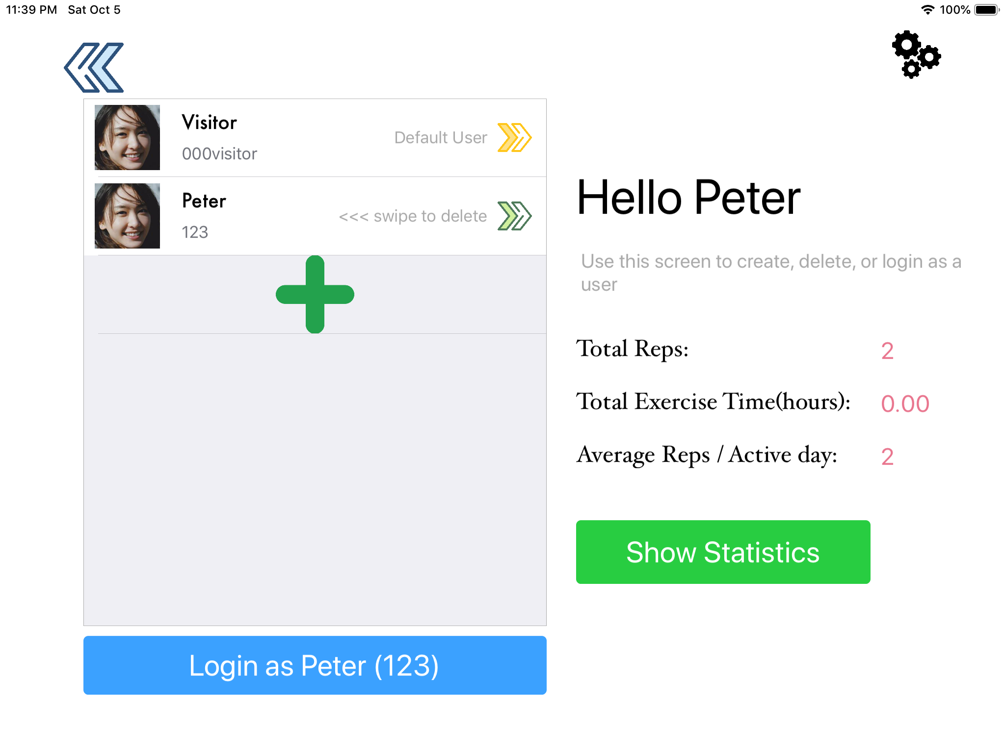

Step 6: To view more statistics. Tap the ‘Show Statistics’ button (above).

Step 7: Tapping ‘Show Statistics’ will display the statistics overview and calendar screen. This screen allows the user to view the users statistics for a desired day (below).

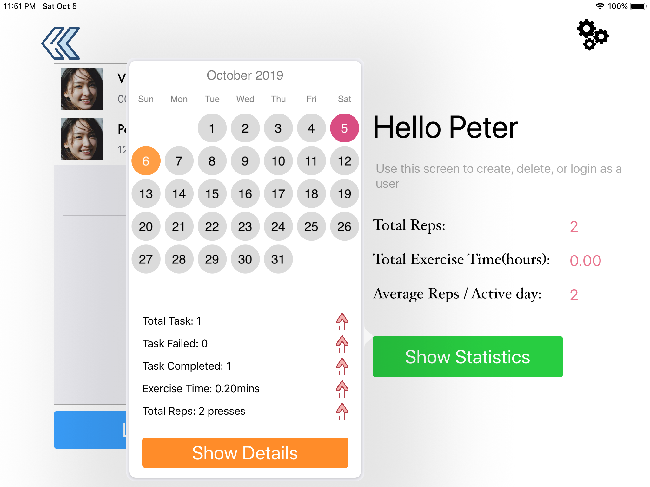

Step 8: To display further statistics tap the ‘Show Details’ button (above).

Step 9: Tapping ‘Show Details’ will display the statistics details page. Here you can view certain statistics in more detail. (below)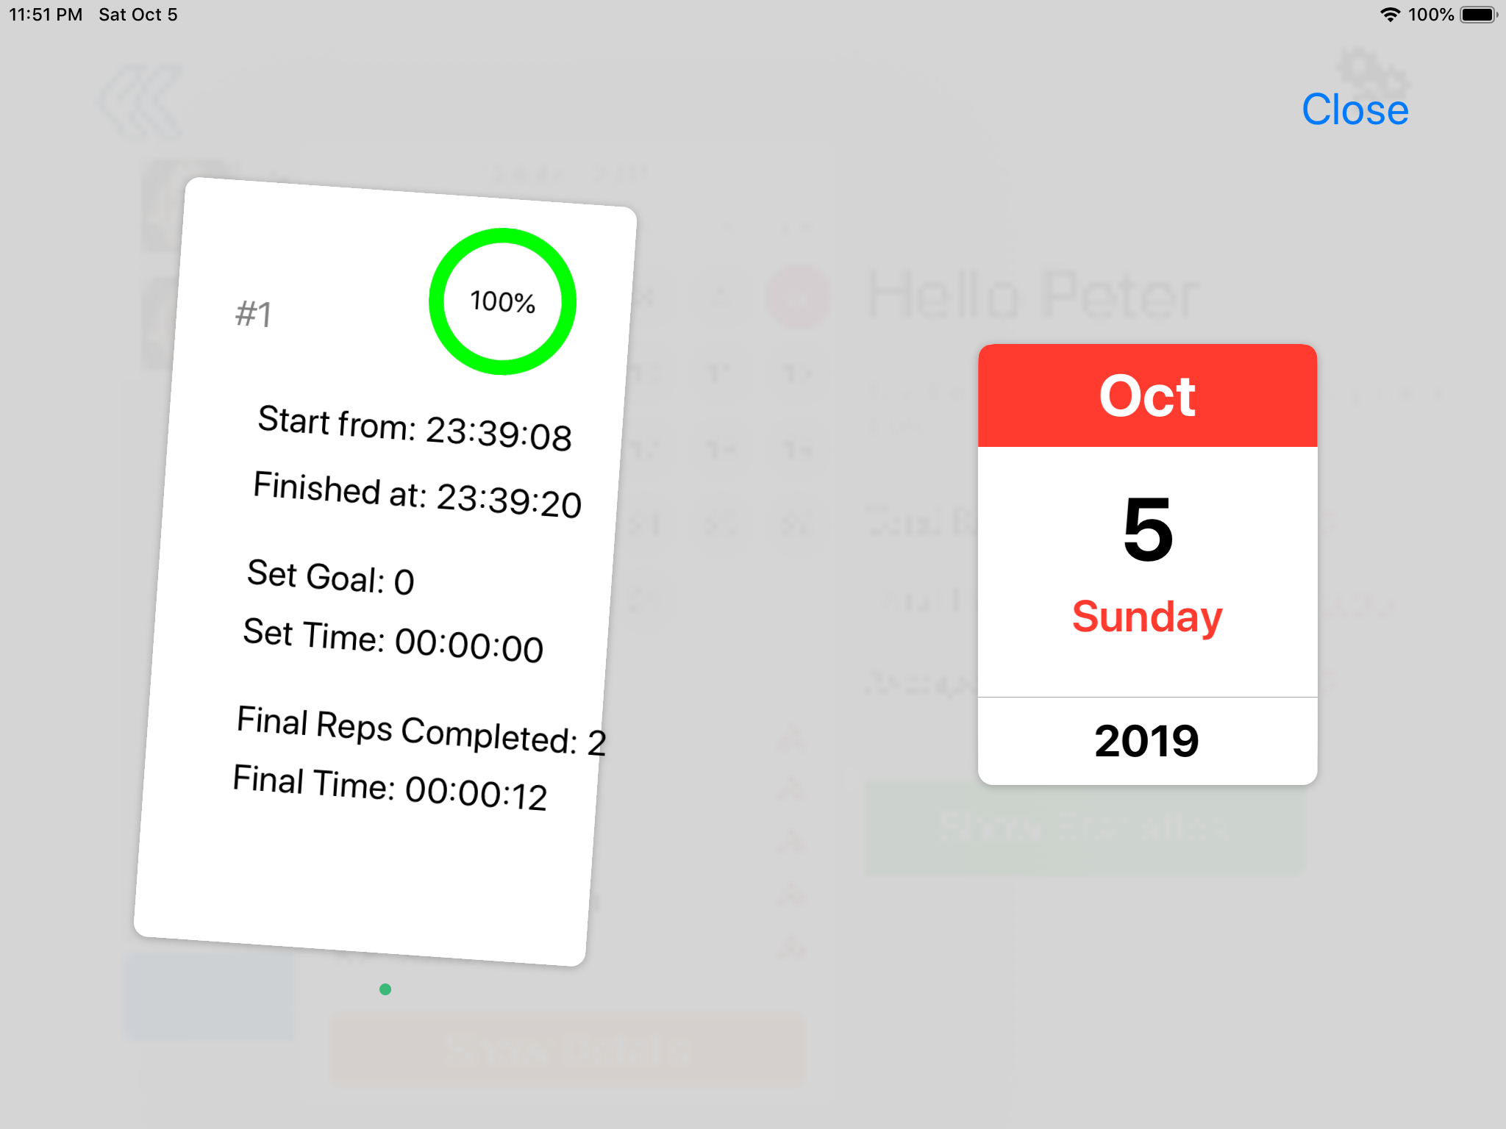

Step 10: To return back to the application, tap ‘Close’ on the top right on the screen.

### **Troubleshooting Show User Statistics.**

**Users statistics are incorrect -**

User statistics are based off the current profile signed in and the goal timer functionality.

To troubleshoot incorrect statistics, ensure that you have followed the troubleshooting steps for both setup and completion of rehabilitation exercise and switch user.

Note: Some issues with statistics exist at a database level and recreation of the user may be necessary.

**User statistics are not displaying -**

See above.

## **Task: Data Export**

Step 1: Open the application to the main screen.

Step 2: Tap the user icon in the top left to open the profile screen (right).

Step 3: From the user profile screen tap the settings icon in the top right of the screen (below).

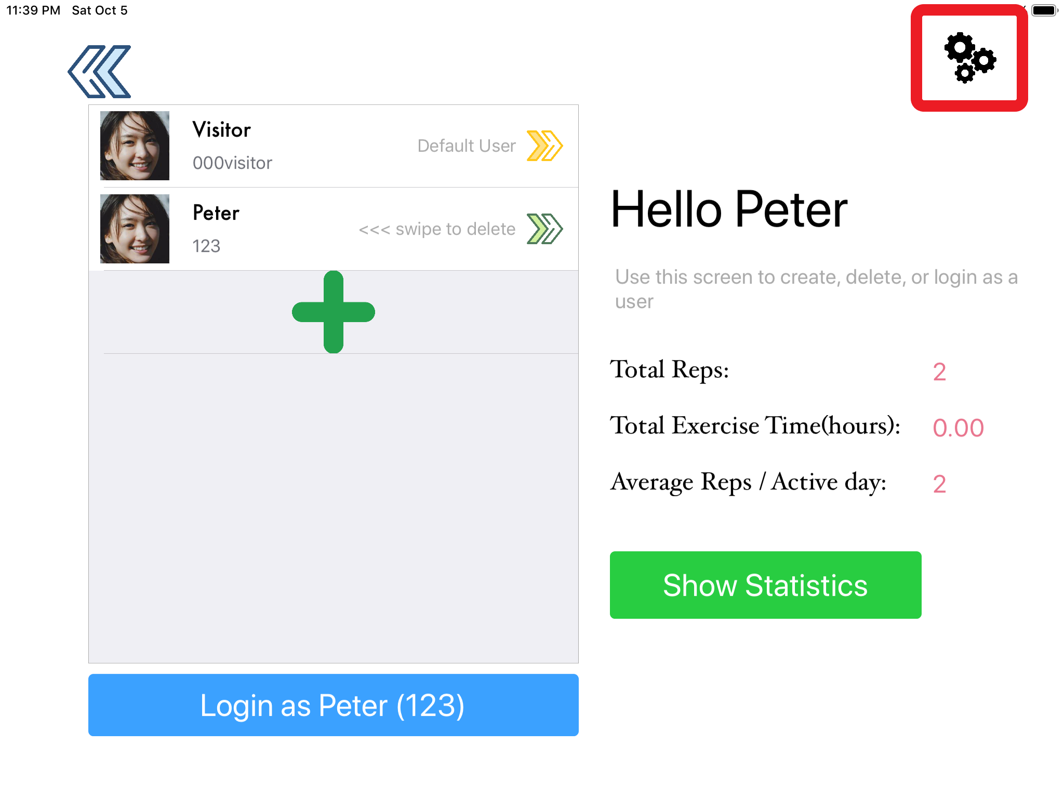

Step 4: Tapping the settings icon will open the settings menu for the profile manager. To export a user’s statistics onto a computer, tap ‘Export Data’. To prevent accidental deletion of user profiles, tap the ‘Delete Prevention’ switch.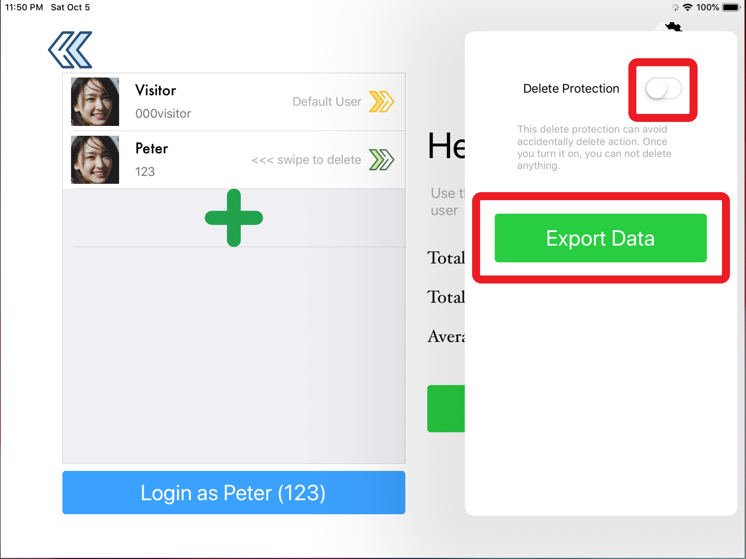

### **Troubleshooting Data Export.**

**Data exported is incorrect -**

To troubleshoot incorrect data, see above.

**Unable to export data off of the iPad or access the saved data -**

Step 1: Ensure that you are saving to a legitimate file location; either the cloud or the iPad.

Step 2: Data saves in a .CSV file. .CSV files are best viewed in spreadsheet applications such as *Microsoft Excel.*

## **General Troubleshooting.**

**Unable to install the application to the iPad -**

Step 1: Ensure the iPad device is connected to the computer properly.   
 Step 2: Ensure the iPad is displayed in the iTunes application.

Step 3: Ensure there is enough storage space on the iPad to install the application.

Step 4: Disconnect and reconnect the iPad from the computer.

Step 5: Restart the computer and the iPad.

**Sound is not playing -**

Step 1: Ensure the iPad is not in silent mode.

Step 2: Ensure there are no headphones currently plugged into the iPad.

Step 3: Ensure that the iPads volume is turned to a sufficient hearing level.

Step 4: Ensure there are no bluetooth earpieces connected to the iPad